**Assignment 1**

1. **Problem statement**
   1. Write an algorithm to check if a node, say A, is good to be the first node to traverse to all the nodes in the network.
   2. Improve your solution to list all the nodes for the given use case, that are good to be initiator node for CL algorithm.
2. **Source Code**

*>> Main_Frame.java*

package *chandi_lamport*;

import *java*.*util*.*Scanner*;

import *java*.*awt*.*FileDialog*;

import *java*.*awt*.*Frame*;

*public* *class* Main_Frame {

*public* *static* void *main*(String[] args) {

        // *Choose graph file*

        String filename = *openFileDialog*();

*if* (filename == null) {

            System.*out*.*println*("No file selected.");

*return*;

        }

        Graph graph = *new* *Graph*(filename);

        // *Display Adjacency Matrix*

        graph.*printAdjacencyMatrix*();

        Scanner scanner = *new* *Scanner*(System.*in*);

        int option;

*do* {

            // *Display menu*

            System.*out*.*println*();

            System.*out*.*println*("Menu:");

            System.*out*.*println*("1. Find initiator with specified name");

            System.*out*.*println*("2. Find initiator without specifying name");

            System.*out*.*println*("0. Exit");

            System.*out*.*print*("Enter your choice: ");

            option = scanner.*nextInt*();

            scanner.*nextLine*(); // *Consume newline character*

*switch* (option) {

*case* 1*:*

                System.*out*.*print*("Enter initiator name: ");

                String initiatorName = scanner.*nextLine*();

                graph.*initiator*(initiatorName);

*break*;

*case* 2*:*

                graph.*initiator*();

*break*;

*case* 0*:*

                System.*out*.*println*("Exiting...");

*break*;

*default:*

                System.*out*.*println*("Invalid option. Please choose again.");

*break*;

            }

        } *while* (option != 0);

        scanner.*close*();

*return*;

    }

*private* *static* String *openFileDialog*() {

        FileDialog fd = *new* *FileDialog*((Frame) null, "Open", FileDialog.*LOAD*);

        fd.*setFilenameFilter*((dir, name) -> name.*endsWith*(".graph"));

        fd.*setVisible*(true);

        String filename = fd.*getFile*();

        // *Validate file extension*

*if* (!filename.*endsWith*(".graph")) {

            System.*out*.*println*("Error: The selected file is not a .graph file.");

            filename = null;

        }

*if* (filename != null) {

*return* fd.*getDirectory*() + filename;

        }

*return* null;

    }

}

*>> Graph.java*

package *chandi_lamport*;

import *java*.*io*.*BufferedReader*;

import *java*.*io*.*FileReader*;

import *java*.*io*.*IOException*;

import *java*.*util*.*ArrayList*;

import *java*.*util*.*Arrays*;

import *java*.*util*.*HashMap*;

import *java*.*util*.*List*;

import *java*.*util*.*Map*;

*public* *class* Graph {

// *Store the vertices from the input file*

*private* *final* List<String> vertices = *new* ArrayList<>();

// *Maps the input vertices with an index*

*private* *final* Map<String, Integer> vertexIndex = *new* HashMap<>();

*private* int[][] adjacencyMatrix;

// *Store the edges from the input file*

*private* List<String> edges = *new* ArrayList<>();

*public* *Graph*(String filename) {

        edges = *readEdgesFromFile*(filename);

*if* (edges == null) {

            System.*out*.*println*("Error reading edges from file.");

*return*;

        }

        // *Identify unique vertices*

*identifyVertices*(edges);

        // *Initialize adjacency matrix*

        adjacencyMatrix = *new* int[vertices.*size*()][vertices.*size*()];

        // *Populate adjacency matrix*

*populateAdjacencyMatrix*(edges, adjacencyMatrix);

    }

// *Read the edges from the file as input*

*private* *static* List<String> *readEdgesFromFile*(String filename) {

        List<String> edges = *new* ArrayList<>();

*try* (BufferedReader br = *new* *BufferedReader*(*new* *FileReader*(filename))) {

            String line;

*while* ((line = br.*readLine*()) != null) {

                edges.*add*(line.*trim*());

            }

        } *catch* (IOException e) {

            e.*printStackTrace*();

*return* null;

        }

*return* edges;

    }

// *Maps the input vertices name with an index*

*private* void *identifyVertices*(List<String> edges) {

*for* (String edge *:* edges) {

            String[] verticesInEdge = edge.*split*(",");

*for* (String vertex *:* verticesInEdge) {

*if* (!vertexIndex.*containsKey*(vertex)) {

                    vertexIndex.*put*(vertex, vertices.*size*());

                    vertices.*add*(vertex);

                }

            }

        }

    }

//*Create adjacency matrix*

*private* void *populateAdjacencyMatrix*(List<String> edges, int[][] adjacencyMatrix) {

*for* (String edge *:* edges) {

            String[] verticesInEdge = edge.*split*(",");

            int i = vertexIndex.*get*(verticesInEdge[0]);

            int j = vertexIndex.*get*(verticesInEdge[1]);

            adjacencyMatrix[i][j] = 1;

        }

    }

// *Print the created adjacency matrix*

*public* void *printAdjacencyMatrix*() {

        System.*out*.*println*("Adjacency matrix of given graph is : ");

        System.*out*.*print*("  ");

*for* (String vertex *:* vertices) {

            System.*out*.*print*(vertex + " ");

        }

        System.*out*.*println*();

*for* (int i = 0; i < adjacencyMatrix.*length*; i++) {

            System.*out*.*print*(vertices.*get*(i) + " ");

*for* (int j = 0; j < adjacencyMatrix[i].*length*; j++) {

                System.*out*.*print*(adjacencyMatrix[i][j] + " ");

            }

            System.*out*.*println*();

        }

        System.*out*.*println*();

    }

// *Perform BFS on the given graph*

*private* Boolean *BFS*(String ini) {

*if* (!vertexIndex.*containsKey*(ini)) {

            System.*out*.*println*(ini + " is not a valid vertex.");

*return* false;

        }

        // *Number of vertices in the graph*

        int noOfNode = vertices.*size*();

        boolean[] visited = *new* boolean[noOfNode];

        Arrays.*fill*(visited, false);

        List<Integer> q = *new* ArrayList<>();

        int iniIndex = vertexIndex.*get*(ini);

        q.*add*(iniIndex);

        // *Set source as visited*

        visited[iniIndex] = true;

        int vis;

*while* (!q.*isEmpty*()) {

            vis = q.*get*(0);

            // *Dequeue*

            q.*remove*(0);

            // *For every adjacent vertex to the current vertex*

*for* (int i = 0; i < noOfNode; i++) {

*if* (adjacencyMatrix[vis][i] == 1 && !visited[i]) {

                    // *Enqueue the adjacent node to the queue*

                    q.*add*(i);

                    visited[i] = true;

                }

            }

        }

*for* (int i = 0; i < noOfNode; i++) {

*if* (!visited[i]) {

                // *If the given vertex is not an initiator return false*

*return* false;

            }

        }

        // *If the given vertex is an initiator return true*

*return* true;

    }

// *Check a given vertex is initiator or not*

*public* void *initiator*(String ini) {

*if* (*BFS*(ini)) {

            System.*out*.*println*(ini + " is an initiator");

        } *else*

            System.*out*.*println*(ini + " is not an initiator");

    }

// *List all initiator vertices*

*public* void *initiator*() {

        System.*out*.*println*("Initiators are: ");

*for* (String ini *:* vertices) {

*if* (*BFS*(ini)) {

                System.*out*.*println*(ini + " is an initiator");

            }

        }

    }

}

1. **Pre-requisites & Assumptions**
2. **Graph File Format**:

It assumes that the input file containing graph edges is formatted correctly, with each line representing an edge between two vertices separated by a comma. The assumption includes consistency in formatting and absence of syntax errors within the file.

<vertex_name1> , <vertex_name2>

1. **Error Handling**:

The code assumes limited error scenarios, primarily focused on file I/O operations. It assumes that file reading operations will encounter no unexpected issues beyond standard IO Exceptions, neglecting potential errors such as missing files, insufficient permissions, or corrupted data. File name must contain “.graph” extension. <filename>.graph

1. **Graph Representation**:

It assumes that the graph is relatively small or sparse enough to justify the memory usage of an adjacency matrix.

1. **Vertex Identification**:

The program assumes that each vertex label is unique and identifiable by a string. It doesn't handle scenarios involving duplicate vertex labels or non-string vertex identifiers, presuming consistent labeling throughout the file.

1. **Initiator Definition**:

The concept of an "initiator" is assumed to represent vertices from which a Breadth-First Search (BFS) traversal can reach all other vertices in the graph.

1. **User Interface**:

It assumes users are accustomed to command-line interfaces and will provide valid inputs as prompted by the program's menu. The assumption includes user compliance with menu options and expected data formats, without considering potential input errors or misuse.

1. **Platform Dependency**:

The program's reliance on AWT components for file dialogs assumes execution within desktop environments supporting AWT libraries. It may not accommodate platforms where AWT is unavailable or impractical, such as web or mobile environments.

1. **Results**
   1. **Graph 1**
      * 1. **Visual Representation of Graph**

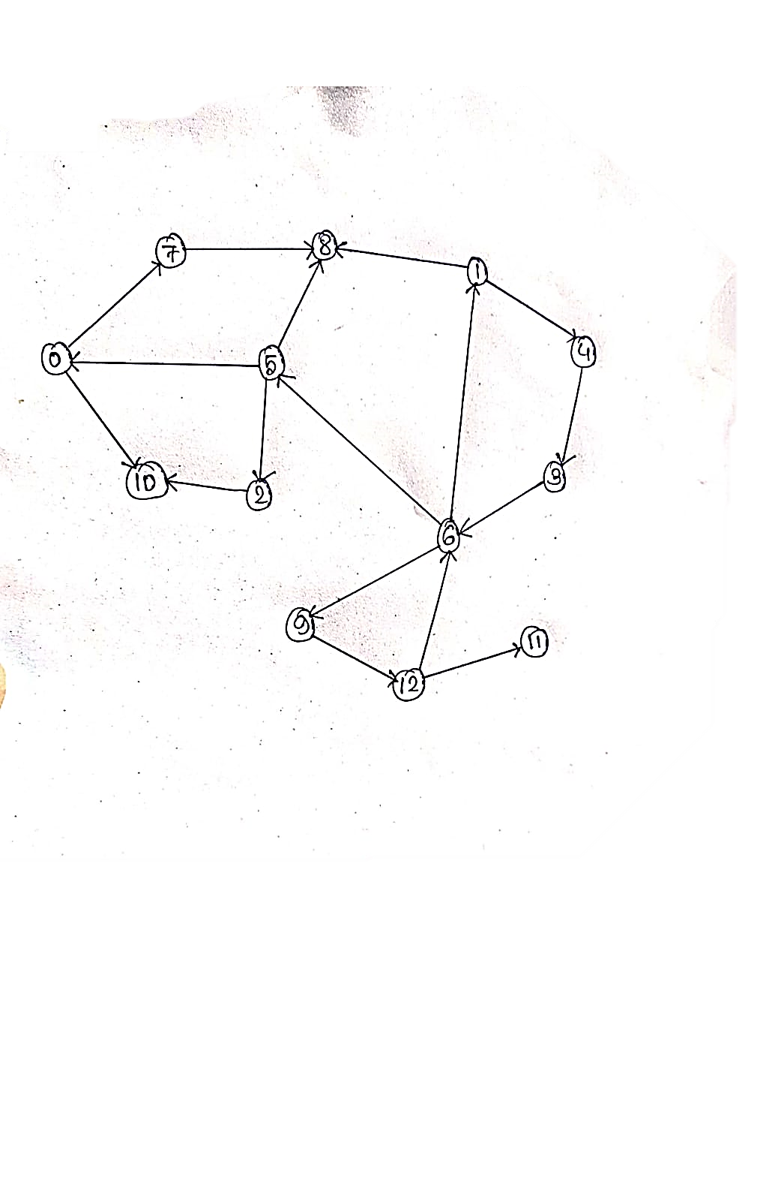

* + - 1. 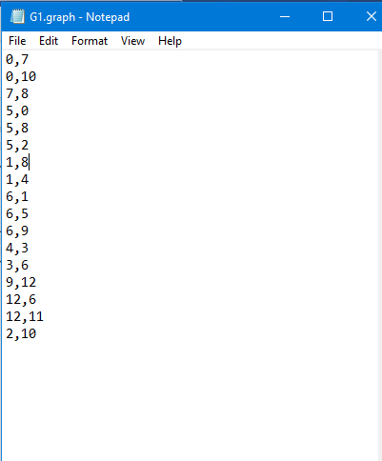 **Graph Input**
      2. **Result**

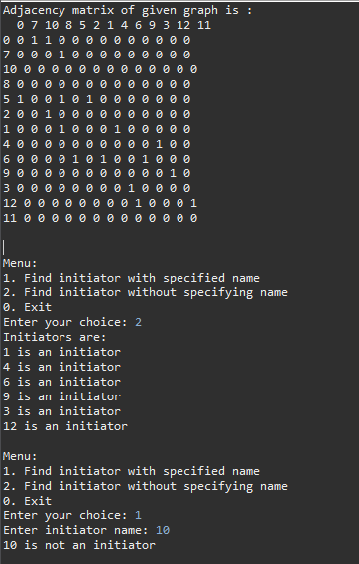

* 1. **Graph 2**
     + 1. 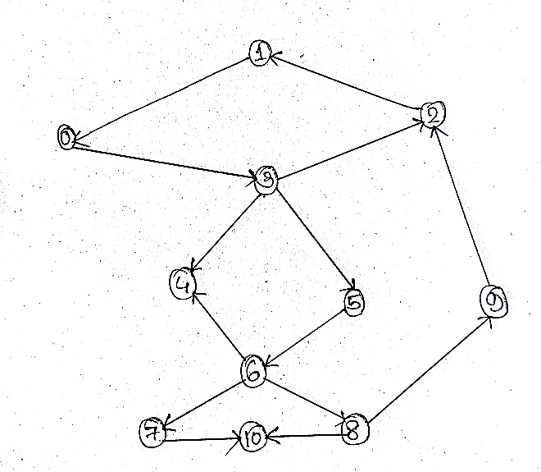 **Visual Representation of Graph**
       2. **Graph Input**

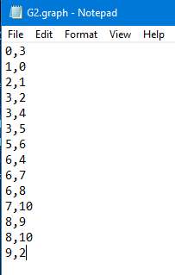

* + - 1. 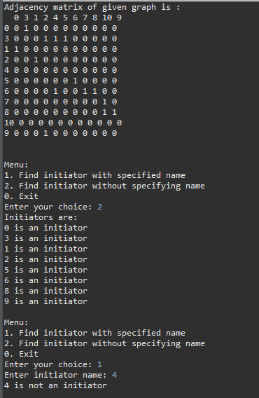 **Result**
  1. **Graph 3**
     + 1. **Visual Representation of Graph**

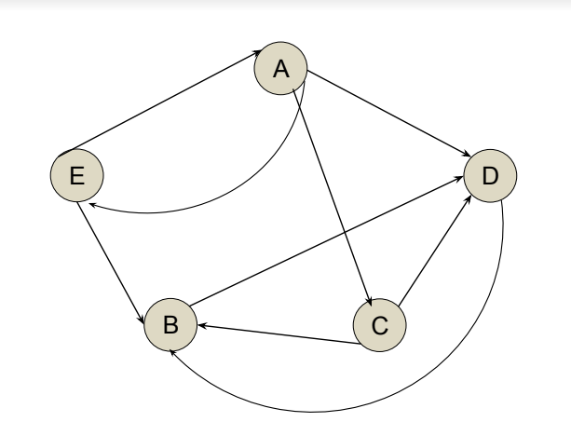

* + - 1. **Graph Input**

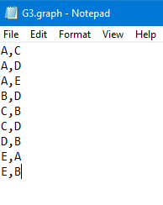

* + - 1. 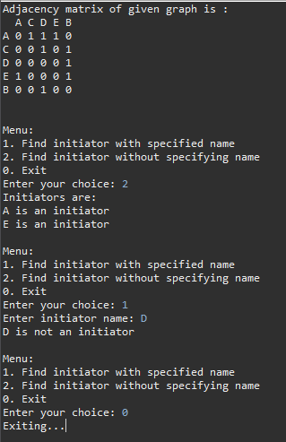 **Result**

1. **Remarks**
   1. **Error Handling Improvement:**

Implement more comprehensive error handling to handle various exceptional scenarios, such as missing or inaccessible files, malformed input data, or unexpected runtime errors. Provide detailed error messages to assist users in troubleshooting issues.

* 1. **Graph Representation Optimization:**

Consider alternative graph representations (e.g., adjacency lists) to reduce memory consumption, especially for large or sparse graphs. Choose a representation that balances memory efficiency with the required operations for the specific application.

* 1. **Input Validation Enhancement:**

Strengthen input validation to ensure robustness against unexpected user inputs. Validate user input formats, handle edge cases gracefully, and provide clear feedback to guide users in providing correct inputs.

* 1. **Code Modularization:**

Further modularize the codebase to enhance maintainability and code reuse. Identify cohesive modules and refactor the code into smaller, reusable components with well-defined responsibilities, adhering to principles such as separation of concerns and single responsibility.